A

Major Project On

### AI MODEL FOR DIGITAL EVALUATION OF DESCRIPTIVE ANSWERS

(Submitted in partial fulfillment of the requirements for the award of Degree) BACHELOR OF TECHNOLOGY

in

COMPUTER SCIENCE AND ENGINEERING

###### By Ch.Mahesh (197R5A0511) P.Hemanth (197R5A0509)

**A.Venkat Vijay (197R5A0512)**

Under the Guidance of

###### A. Kiran Kumar

(Assistant Professor)



**DEPARTMENT OF COMPUTER SCIENCE AND ENGINEERING**

**CMR TECHNICAL CAMPUS**

**UGC AUTONOMOUS**

(Accredited by NAAC, NBA, Permanently Affiliated to JNTUH, Approved by AICTE, New Delhi) Recognized Under Section 2(f) & 12(B) of the UGC Act.1956

Kandlakoya (V), Medchal Road, Hyderabad-501401.

**2018-22**

### DEPARTMENT OF COMPUTER SCIENCE AND ENGINEERING



**CERTIFICATE**

This is to certify that the project entitled “**AI MODEL FOR DIGITAL EVALUATION OF DESCRIPTIVE ANSWERS**” being submitted by **Ch.Mahesh(197R5A0511), P.Hemanth(197R5A0509) & A.Venkat Vijay(197R5A0512)** in partial fulfillment of the requirements for the award of the degree of B.Tech in Computer Science and Engineering to the Jawaharlal Nehru Technological University Hyderabad, is a record of bonafide work carried out by him/her under our guidance and supervision during the year 2021-22.

The results embodied in this thesis have not been submitted to any other University or Institute for the award of any degree or diploma.

**A. Kiran Kumar Dr. A. Raji Reddy**

**(Assistant Professor) DIRECTOR**

**INTERNAL GUIDE**

**Dr. K. Srujan Raju EXTERNAL EXAMINER**

**HoD**

**Submitted for viva voice Examination held on**

##### ACKNOWLEDGEMENT

Apart from the efforts of us, the success of any project depends largely on the encouragement and guidelines of many others. We take this opportunity to express our gratitude to the people who have been instrumental in the successful completion of this project. We take this opportunity to express my profound gratitude and deep regard to my guide

**A. Kiran Kumar,** Assistant Professor for his exemplary guidance, monitoring and constant encouragement throughout the project work. The blessings, help and guidance given by him shall carry us a long way in the journey of life on which we are about to embark. We also take this opportunity to express a deep sense of gratitude to Project Review Committee (PRC) **Mr. J. Narasimha Rao, Dr. T. S. Mastan Rao, Dr. Suwarna Gothane, Mr. A. Uday Kiran, Mr. A. Kiran Kumar, Mrs. G. Latha** for their cordial support, valuable information and gu i d a n c e , w h i c h he l p e d us i n c o m p l e t i n g t h i s t a s k t h r o u g h va r i o u s s t a g e s .

We are also thankful to **Dr. K. Srujan Raju,** Head, Department of Computer Science and Engineering for providing encouragement and support for completing this project successfully.

We are obliged to **Dr. A. Raji Reddy,** Director for being cooperative throughout the course of this project. We also express our sincere gratitude to Sri. **Ch. Gopal Reddy,** Chairman for providing excellent infrastructure and a nice atmosphere throughout the course of this project.

The guidance and support received from all the members of **CMR Technical Campus** who contributed to the completion of the project. We are grateful for their constant support and help.

Finally, we would like to take this opportunity to thank our family for their constant encouragement, without which this assignment would not be completed. We sincerely acknowledge and thank all those who gave support directly and indirectly in the completion of this project.

**Ch.Mahesh (197R5A0511) P.Hemanth (197R5A0509)**

**A.Venkat Vijay(197R5A0512)**

##### ABSTRACT

Nowadays, where the world is moving towards automation so, there is a necessity for automation in educational institutions as well. The manual system for evaluation of descriptive answers involves a lot of time & efforts of the evaluator. When the teacher evaluates any paper manually, the quality of evaluation may vary along with the emotions of the teacher. Hence, the marks distribution can sometimes be inappropriate. Our proposed system can be used instead in order to reduce their burden & allot marks equally. Our system will use machine learning to solve this problem. In Machine Learning, all result is only based on the input data provided. It will evaluate the answer based on the keywords, only one has to scan the paper then, the system will provide the marks according to the dataset present. The main aim of the project is to ensure user-friendly and more interactive software to the institution. Performing evaluation through our system will ensure uniformity in marking as the same inference mechanism will be used for all students.

### LIST OF FIGURES

|  |  |  |
| --- | --- | --- |
| **FIGURE NO** | **FIGURE NAME** | **PAGE NO** |
| Figure 3.1 | Project Architecture | 6 |
| Figure 3.2 | Use case diagram | 8 |
| Figure 3.3 | Class diagram | 9 |
| Figure 3.4 | Sequence diagram | 10 |
| Figure 3.5 | Activity diagram | 11 |

### LIST OF SCREENSHOTS

|  |  |  |
| --- | --- | --- |
| **SCREEN SHOT NO.** | **SCREEN SHOT NAME** | **PAGE NO** |
| Screenshot 5.1 | STUDENT INTERFACE | 20 |
| Screenshot 5.2 | CHECKING MAIL FORMAT | 20 |
| Screenshot 5.3 | WRITING ANSWERS | 21 |
| Screenshot 5.4 | EXAM SUBMISSION | 22 |
| Screenshot 5.5 | MARKS ALLOCATION | 22 |
| Screenshot 5.6 | DATASET COLLECTOR SNIPPET | 23 |
| Screenshot 5.7 | MODEL ANSWERS | 24 |
| Screenshot 5.8 | GIV_VAL SNIPPET | 24 |
| Screenshot 5.9 | NAV_TEST SNIPPET | 25 |

**TABLE OF CONTENTS**

**ABSTRACT** i

LIST OF FIGURES ii

LIST OF SCREENSHOTS iii

1. INTRODUCTION 1
   1. PROJECT SCOPE 1
   2. PROJECT PURPOSE 1
   3. PROJECT FEATURES 1
2. SYSTEM ANALYSIS 2
   1. PROBLEM DEFINITION 2
   2. EXISTING SYSTEM 2
      1. LIMITATIONS OF THE EXISTING SYSTEM 3
   3. PROPOSED SYSTEM 3
      1. ADVANTAGES OF PROPOSED SYSTEM 3
   4. FEASIBILITY STUDY 3
      1. ECONOMIC FEASIBILITY 4
      2. TECHNICAL FEASIBILITY 4
      3. SOCIAL FEASIBILITY 4
   5. HARDWARE & SOFTWARE REQUIREMENTS 5
      1. HARDWARE REQUIREMENTS 5
      2. SOFTWARE REQUIREMENTS 5
3. ARCHITECTURE 6
   1. PROJECT ARCHITECTURE 6
   2. MODULE DESCRIPTION 7
   3. USE CASE DIAGRAM 8
   4. CLASS DIAGRAM 9\
   5. SEQUENCE DIAGRAM 10
   6. ACTIVITY DIAGRAM 11
4. IMPLEMENTATION 12
   1. SAMPLE CODE 12
5. SCREENSHOTS 20
6. TESTING 26
   1. INTRODUCTION TO TESTING 26
   2. TYPES OF TESTING 26
      1. UNIT TESTING 26
      2. INTEGRATION TESTING 26
      3. FUNCTIONAL TESTING 27
   3. TEST CASES 27
      1. WRITING TEST 27
      2. EVALUATION 27
7. CONCLUSION & FUTURE SCOPE 28
   1. PROJECT CONCLUSION 28
   2. FUTURE SCOPE 28
8. REFERENCES 29
   1. REFERENCES 29
   2. GITHUB REPOSITORY LINK 29
9. JOURNAL 30

# 1.INTRODUCTION

### INTRODUCTION

##### PROJECT SCOPE

Computer based evaluation of student answer is the common work which is used in many areas in assessment of students learning process. The computer assisted assessment system is developed to evaluate the one word answer such as of multiple choice questions. Andcan also evaluate the paragraph answer such as descriptive answer based on the keyword matching. This system can be widely used in academic institutions for checking answer sheets. It can also be implemented in different organizations which conduct competitive examinations. Student writes answer on answer-sheet. The system will take scanned copy of the answer as an I/P & then after the preprocessing step it will extract the text of the answer. Model answer sets will be provided by the moderator/evaluator. This model answers will be then trained. The evaluator also provides with the keywords and Question Specific Things. Model answer sets and keywords categorized as mentioned will be the input as well. This system is based on three parameters i.e. Keywords, Grammar and Question Specific Things.

* 1. PROJECT PURPOSE

The revolution in technology reduces the effort of manpower in many of the areas. the boon of the technology and rapid advancements in education industry has provided a good learning environment. It offers qualification and credits at the desktop through online courses and evaluation. The prevailing system has its own pause in terms of volume, staffing, variation in the strategies of assessing. As of now, the objective-type questions alone can be practiced and assessed through online examination.

* 1. PROJECT FEATURES

The main features of this project are that the designer now functions as a problem solver and tries to sort out the difficulties that the Evaluators faces. The solutions are given as proposals. The proposal is then weighed with the existing system analytically and the best one is selected. The aim of the project is to propose a system which will evaluate student performance on the basis of the descriptive answers. In order to accomplish this, we will take handwritten scanned answer sheet of descriptive answers from students. The scanned answer sheet, keywords, minimum length of the answer will be provided by the moderator as input to the system.

# 2.SYSTEM ANALYSIS

### 2.SYSTEM ANALYSIS

##### SYSTEM ANALYSIS

System Analysis is the important phase in the system development process. the System is studied to the minute details and analysed. The system analyst plays an important role of an interrogator and dwells deep into the working of the present system. In analysis, a detailed study of these operations performed by the system and their relationships within and outside the system is done. A key question considered here is, “what must be done to solve the problem?” The system is viewed as a whole and the inputs to the system are identified. Once analysis is completed the analyst has a firm understanding of what is to be done.

* 1. PROBLEM DEFINITION

The manual system for evaluation of Descriptive Answers for technical subjects involves a lot of time and effort of the evaluator. Descriptive answers have various parameters upon which they can be evaluated such as the question specific content and writing style. Evaluating subjective answers is a critical task to perform. When human being evaluates anything, the quality of evaluation may vary along with the emotions of the person. This system can be used instead in order to reduce their burden. It will save a lot of effort and time on teacher’s part. The human efforts applied in this repetitive task can be saved and spent more in other academic endeavors. The obvious human mistakes can be reduced to obtain an unbiased result. The system calculates the score and provides results fairly quickly

* 1. EXISTING SYSTEM

There are many existing evaluating systems which were divided into three mainphases which includes prediction of best answers for short questions using NLP, essay type long answer evaluation using tools and technologies such as sentence splitting, POS tagging, wordnet and tokenizing. In the final phase, an approach for qualitative evaluation of structured answers using keyword analysis and sentence analysis is explained. Another technique to evaluate descriptive answers by matching keywords in an answer key to the keywords and phrases in the answer base.

##### LIMITATIONS OF EXISTING SYSTEM

* + - * Time consuming.
      * Tedious process.
      * The existing systems are only capable of evaluating MCQ type questions andthere is a need for a system to evaluate subjective answers.

To avoid all these limitations and make the working more accurately the system needs to be implemented efficiently.

##### PROPOSED SYSTEM

The proposed system AI comes with the opportunity of making a tedious and tiresome task in the field of education more efficient and less time consuming. The use of artificial intelligence to get optimized solutions in the form of marks obtained by the student is the core principle of the proposed system. The input answer sheets of the student will get compared to the model answer sheet by the evaluator and will then generate the final score based on multiple parameters. The various parameters will be sentence splitting, Jaccard similarity, grammar checking and sentence similarity. In this system OCR will be used to convert handwritten student answers into digital letters. Splitting the model answer and student answer into sentences and then applying Jaccard similarity, grammar checking and algorithm for sentence similarity using BERT on both the texts. Assigning marks based on weighted average and displaying the score obtained by the student.

##### ADVANTAGES OF THE PROPOSED SYSTEM

The system is very simple in design and to implement. The system requires very low system resources and the system will work in almost all configurations. It got following features

* + - * It is faster and effective than the previous existing system.
      * Better service.
      * Minimum time required.
      * Artificial intelligence can help tackle this by not omitting human errors.

##### FEASIBILITY STUDY

The feasibility of the project is analysed in this phase and business proposal is put forth with a very general plan for the project and some cost estimates. During system analysis the feasibility study of the proposed system is to be carried out. This is to ensure that the proposed system is not a burden to the company. Three key considerations involved in the feasibility analysis are

* Economic Feasibility
* Technical Feasibility
* Social Feasibility

##### ECONOMIC FEASIBILITY

The developing system must be justified by cost and benefit. Criteria to ensure that effortis concentrated on project, which will give best, return at the earliest. One of the factors, which affect the development of a new system, is the cost it would require.

The following are some of the important financial questions asked during preliminary investigation:

* + - * The costs conduct a full system investigation.
      * The cost of the hardware and software.
      * The benefits in the form of reduced costs or fewer costly errors.

Since the system is developed as part of project work, there is no manual cost to spend for the proposed system. Also all the resources are already available, it give an indication of the system is economically possible for development.

##### TECHNICAL FEASIBILITY

This study is carried out to check the technical feasibility, that is, the technical requirements of the system. Any system developed must not have a high demand on the available technical resources. The developed system must have a modest requirement, as onlyminimal or null changes are required for implementing this system.

##### BEHAVIOURAL FEASIBILITY

This includes the following questions:

* + - * Is there sufficient support for the users?
      * Will the proposed system cause harm?

The project would be beneficial because it satisfies the objectives when developed and installed. All behavioural aspects are considered carefully and conclude that the project is behaviourally feasible.

##### HARDWARE & SOFTWARE REQUIREMENTS

##### HARDWARE REQUIREMENTS:

Hardware interfaces specifies the logical characteristics of each interface between the software product and the hardware components of the system. The following are some hardware requirements.

* + - * Processor : Intel i3.
      * Hard disk : 100GB.
      * RAM : 4GB.

##### SOFTWARE REQUIREMENTS:

Software Requirements specifies the logical characteristics of each interface and software components of the system. The following are some software requirements,

* + - * Operating system : Windows 7/8/10.
      * Language : Python.
      * IDE : PyCharm.

# ARCHITECTURE

### 3.ARCHITECTURE

##### PROJECT ARCHITECTURE

This project architecture shows the procedure followed for AI Model for Digital Evaluation of Descriptive Answers

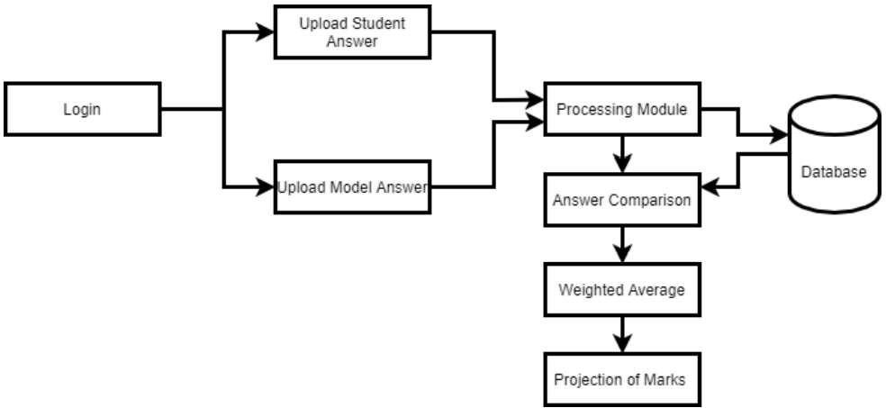

Figure 3.1: Project Architecture

##### MODULE DESCRIPTION

**Login:** The admin is authenticated using his user id and password. Once authentication is done, the admin can add questions and their respective answers in the database. The admin can also add subjects, students and tests for those students. The admin needs to keep all the keywords from the answer in capital letters. The user logs in with test test link given by the admin password If all the credentials are satisfied then the student is redirected to the page where the question and a text box for the answer is displayed. The user can then write the answer for the question displayed. After completing the answer, he or she can submit the answer for evaluation.

**Upload Answers:** The students answers are uploaded and sent to Processing Module and the Model Answers are also uploaded and sent to Processing Module.The answer is a subjective response from the student that is to be evaluated. It usually contains some or all of the keywords and spans 1 to a few sentences depending on the type of question and the student’s writing style. It almost always contains synonym words compared to the solution and, therefore,requires much more semantic care when processing.

**Processing Module**: In this Module the Answers are Processed and sent to Database After taking inputs from the user, both the solution and the answer go through some preprocessing steps, which involve tokenization, stemming, lemmatization, stop words removal,case folding, ﬁnding, and attaching synonyms to the text

**Database:** Database is used to store the data and to get data when required. Here in this data base the model answer is uploaded by the admin and the solution which is uploaded bay the student is also stored these model answers and the solutions are further used to train the model and evaluate the solutions subbmitted by the student. The database also stores the marks secured by the students .

**Answer Comparison:** The Student Answers and Model Answers are Compared in this Module.After taking inputs from the user, both the solution and the answer go through some preprocessing steps, which involve tokenization, stemming, lemmatization, stop words removal,case folding, ﬁnding, and attaching synonyms to the text

**Results**: In this Module the Answers are Weighted and Marks are Projected to the User. It takes input from the learning module and validates the overall score with the class obtained from the learning module.Suppose the class matches the score. The score is considered ﬁnalized. If the class does not match the score, then the addition or deduction of half the number of values in that range is made based on whether the model suggested score is greater or lesser than the Similarity equivalent score

##### USE CASE DIAGRAM

In the use case diagram we have basically one actor that is user. The user has the rights to login, access to resources and to view the details.

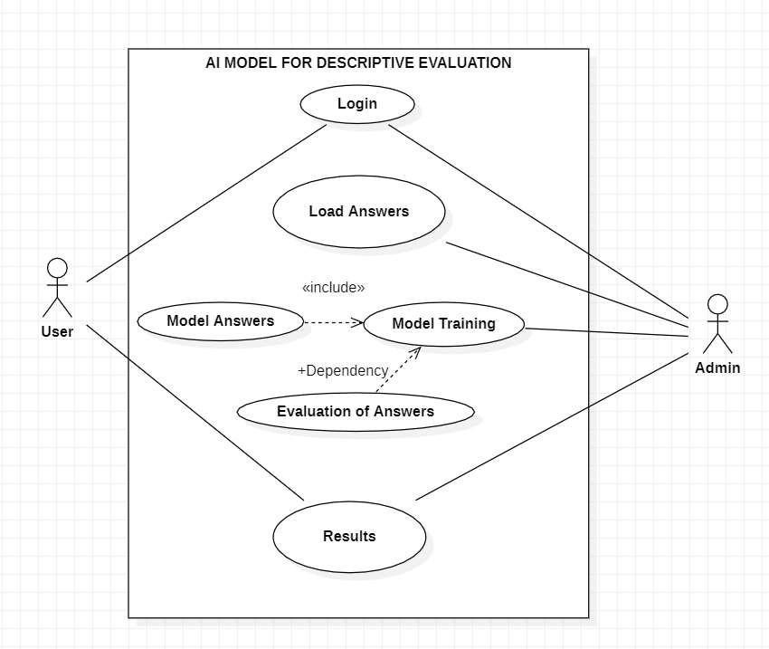

Figure 3.2: Use Case Diagram of AI Model for Digital Evaluation of Descriptive Answers

##### CLASS DIAGRAM

Class Diagram is a collection of classes and objects.

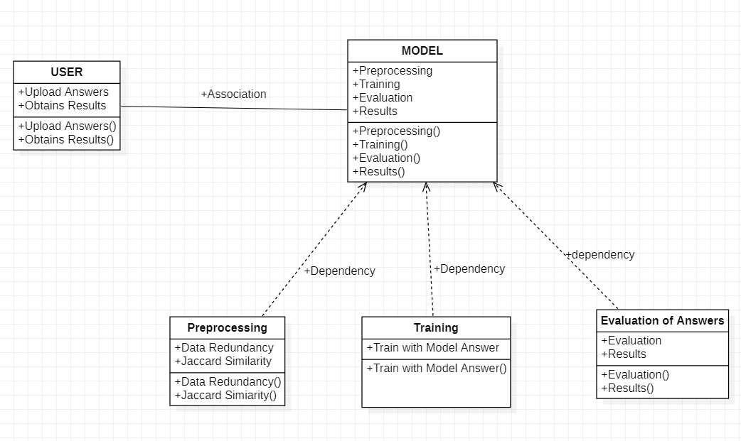

Figure 3.3: Class Diagram of AI Model for Digital Evaluation of Descriptive Answers.

##### SEQUENCE DIAGRAM

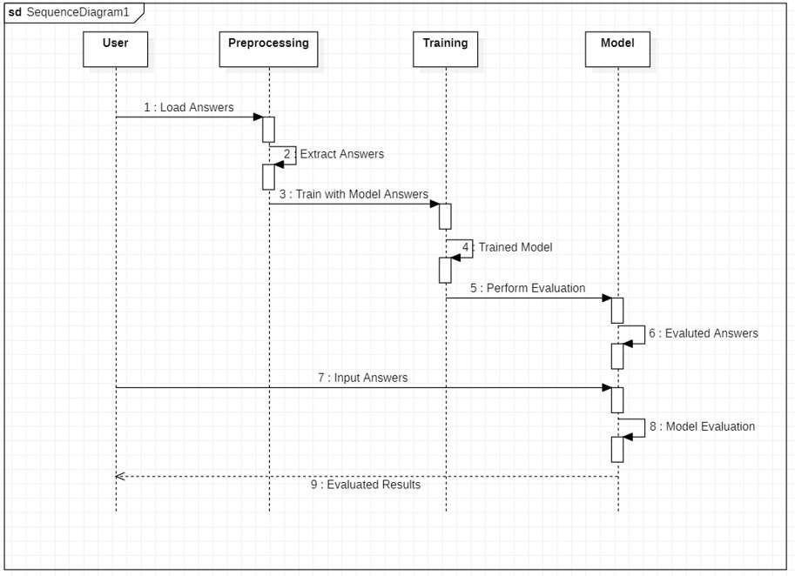

Figure 3.4: Sequence Diagram of AI Model for Digital Evaluation of Descriptive Answers

##### ACTIVITY DIAGRAM

It describes about flow of activity states.

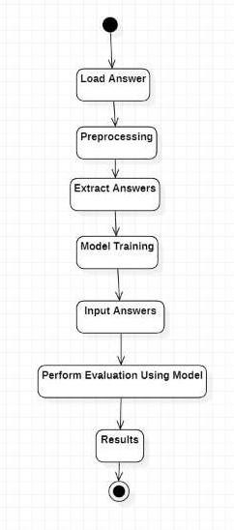

Figure 3.5: Activity Diagram of AI Model for Digital Evaluation of Descriptive Answers.

# 4.IMPLEMENTATION

##### IMPLEMENTATION

##### 4.1 SAMPLE CODE

from flask import Flask, render_template, request import json

import os

app = Flask( name )

email = "null" @app.route('/')

def Base_qstn_paper_set():

return render_template('first.html') @app.route('/foo', methods=['POST', 'GET']) def foo():

if request.method == 'POST': first = request.form['first']

second = request.form['second'] hird = request.form['third']

email = request.form['emailID']

ans = {"a1": first, "a2": second, "a3": third, "email": email} json_object = json.dumps(ans, indent=4)

if os.path.exists("data/"+email+"[mahesh@gmail.com.json](mailto:mahesh@gmail.com.json)")==False:

with open("data/" + email + "[mahesh@gmail.com.json](mailto:mahesh@gmail.com.json)", "w") as outfile: outfile.write(json_object)

return render_template('Exam_end.html') else:

return render_template('exist_student.html') if name == ' main ':

app.run()

import json import os import math import re

import pandas as pd import nav_test

from fuzzywuzzy import fuzz

# TODO- Accuracy prediction library '''

e = 1

vg = 2

g = 3

o = 4

p = 5

vp = 6 Grammar:

y = 1

n = 0

def givVal(model_answer, keywords, answer, out_of):

# KEYWORDS =>>>>>>>>>>>>>>>>>>>>>>>>>>>>>>>>>>>>>>>>>>

# TODO : Enhacnce this thing if (len(answer.split(" "))) <= 5:

return 0

count = 0

keywords_count = len(keywords) for i in range(keywords_count):

if keywords[i] in answer:

count = count + 1

k = 0

if count == keywords_count: k = 1

elif count == (keywords_count -1): k = 2

elif count == (keywords_count -2): k = 3

elif count == (keywords_count - 3): k = 4

elif count == (keywords_count - 4): k = 5

elif count == (keywords_count - 5): k = 6

g=1

# QST =>>>>>>>>>>>>>>>>>>>>>>>>>>>>>>>>>>>>>>>>>>>>>>>

#print("fuzz1 ratio: ", fuzz.ratio(model_answer, answer))

q = math.ceil(fuzz.token_set_ratio(model_answer, answer) * 1 / 100)

#print("Keywords : ", k) #print("Grammar : ", g) #print("QST : ", q)

predicted = nav_test.predict(k, g, q) # Mathematical model->

# predicted / 10

# what? / out_of

result = predicted * out_of / 10 return result[0]

dat=[]

directory = "../temp"

for filename in os.listdir(directory):

f = os.path.join(directory, filename) if os.path.isfile(f):

x = open(f, 'r', encoding="cp866") dat.append(json.load(x))

model_answer1 = dat[0]['answer'] out_of1 = dat[0]['out_of'] keywords1 =dat[0]['keywords']

keywords1 = re.findall(r"[a-zA-Z]+", keywords1)

model_answer2 = dat[1]['answer'] out_of2 = dat[1]['out_of'] keywords2 =dat[1]['keywords']

keywords2 = re.findall(r"[a-zA-Z]+", keywords2)

model_answer3 = dat[2]['answer'] out_of3 = dat[2]['out_of'] keywords3 =dat[2]['keywords']

keywords3 = re.findall(r"[a-zA-Z]+", keywords3)

keywords=[keywords1,keywords2,keywords3] directory="../DataSetCollectorFlaskApp/data"

result=0 model_answers=[model_answer2,model_answer2,model_answer3] out_ofs=[out_of1,out_of2,out_of3]

studentReport=[] StudentEmail=[] StudentMarks=[] marksperQ=[]

for filename in os.listdir(directory):

f = os.path.join(directory, filename) if os.path.isfile(f):

x=open(f)

data = json.load(x) result=0

answers=[data['a1'],data['a2'],data['a3']] results = []

for xx in range(3): results.append(result)

result =result+ givVal(model_answers[xx], keywords[xx], answers[xx],

out_ofs[xx])

StudentMarks.append(result) StudentEmail.append(data["email"]) marksperQ.append(results)

ToatalReport=pd.DataFrame(list(zip(StudentEmail,StudentMarks)))

ToatalReport.columns = ['Student Name','Total Marks']

ToatalReport.index +=1 print(ToatalReport)

{ "answer":

"Encapsulation is an object-oriented programming concept that binds together the data and functions that manipulate the data, and that keeps both safe from outside interference and misuse.Data encapsulation led to the important OOP concept of data hiding. If a class does not allow calling code to access internal object data and permits access through methods only, this is a strong form of abstraction or information hiding known as encapsulation. Data encapsulation is a mechanism of bundling the data, and the functions that use them and data abstraction is a mechanism of exposing only the interfaces and hiding the implementation details from the user. Abstraction and encapsulation are complementary concepts: abstraction focuses on the observable behavior of an object. encapsulation focuses upon the implementation that gives rise to this behavior. encapsulation is most often achieved through information hiding, which is the process of hiding all of the secrets of object that do not contribute to its essential characteristics. Encapsulation is the process of combining data and functions into a single unit called

class. In Encapsulation, the data is not accessed directly; it is accessed through the functions present inside

the class. In simpler words, attributes of the class are kept private and public getter and setter methods are provided to manipulate these attributes. Thus, encapsulation makes the concept of data hiding possible Abstraction is a process where you show only “relevant” data and “hide” unnecessary details of an object from the user.",

"keywords": "['binds', 'together', 'relevant data', 'data hiding', 'data hiding', 'abstraction', 'combining data']"

, "out_of": 5

}

{

"answer":

"Asymptotic Notations are languages that allow us to analyze an algorithm's running time by identifying its behavior as the input size for the algorithm increases. This is also known as an algorithm's growth rate. Main Types - 1. Big 2.Small 1. Big Notation further divided into three types- 1)Big O 2)Big Omega 3)Big Theta 2. Small Notation further divided into three types- 1)Small o 2)Small Theta",

"keywords": "['Analysing Algorithm', 'analyse running time','represent time complexity of algorithms','measure the efficiency']",

"out_of": 5

}

{

"answer": "Polymorphism means to process objects differently based on their data type. In other

words it means, one method with multiple implementation, for a certain class of action. And which implementation to be used is decided at runtime depending upon the situation (i.e., data type of the object) This can be implemented by designing a generic interface, which provides generic methods for a

certain class of action and there can be multiple classes, which provides the implementation of these generic methods. In object-oriented programming, polymorphism refers to a programming language&#39;s ability to process objects differently depending on their data type or class. More specifically, it is the ability to redefine methods for derived classes. 1) Static Polymorphism also known as compile time polymorphism - Polymorphism that is resolved during compiler time is known as static polymorphism. Method overloading is an example of compile time polymorphism.2) Dynamic Polymorphism also known as runtime polymorphism - It is also known as Dynamic Method Dispatch. Dynamic polymorphism is a process in which a call to an overridden method is resolved at runtime, that is why it is called runtime polymorphism.",

"keywords": "['one name many forms' , 'generic interface', 'implementation', 'runtime', 'same method name', 'same function name']",

"out_of": 5

}

from sklearn.naive_bayes import GaussianNB import pandas as pd

import numpy as np import pickle

df = pd.read_csv('finaldataset.csv') xf = df[['keyword', 'grammar', 'qst']] # intigrate keyword, grammar, qst :) ''''

keywords and qst: e = 1

vg = 2

g = 3

o = 4

p = 5

vp = 6

Grammar:

y = 1

n = 0

class labels 0.1 to 0.9 simplifies to 0 to 9 for calculation purpose '''

x = np.array(xf.values) yf = df[['class']]

y = np.array(yf.values).ravel() clf = GaussianNB() clf.fit(x,y)

with open('nav_test.pickle','wb') as f: pickle.dump(clf, f)

pickle_in = open('nav_test.pickle', 'rb') clf = pickle.load(pickle_in)

def predict(k, g, q):

predicted = clf.predict([[k, g, q]]) accuracy = clf.predict_proba([[k, g, q]]) #print("class[1-9] : " + str(predicted)) #print(accuracy) print(np.max(accuracy))

return p

# SCREEN SHOTS



* + 1. **SCREEN SHOTS**
  1. **STUDENT INTERFACE**

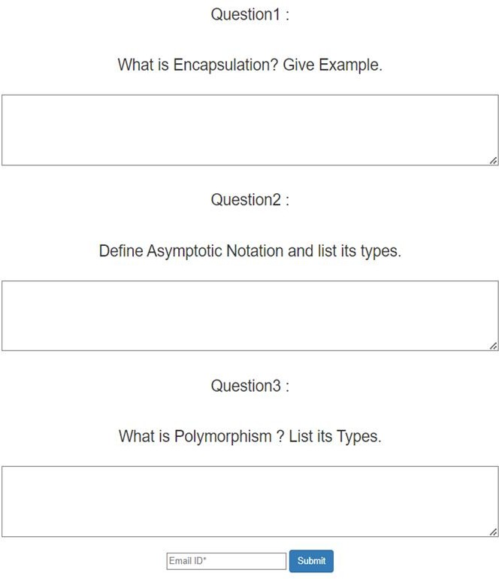

* 1. **CHECKING MAIL FORMAT**
  2. **WRITING ANSWERS**

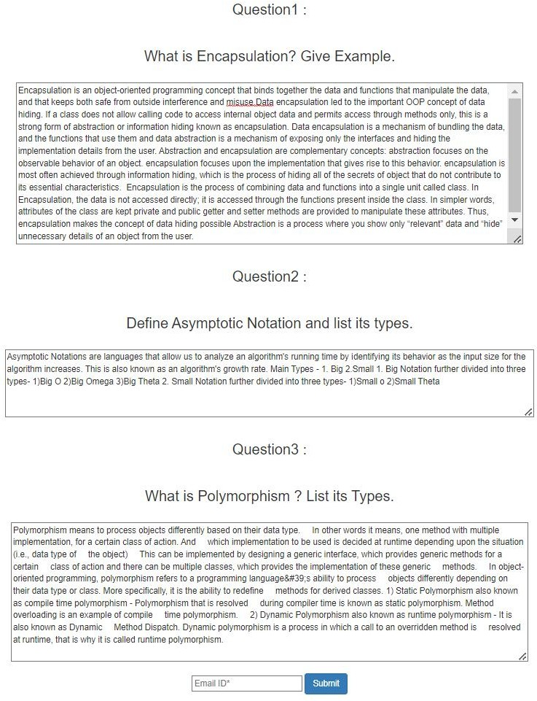

**5.4. EXAM SUBMISSION**



* 1. **MARKS ALLOCATION**

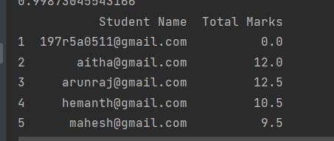

* 1. **DATA SET COLLECTOR SNIPPET**

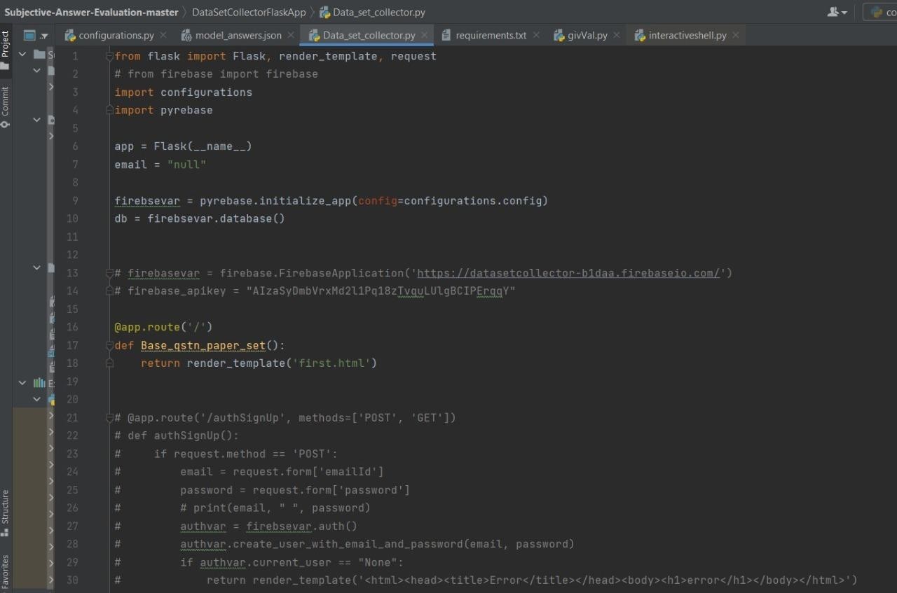

* 1. **MODEL ANSWERS**

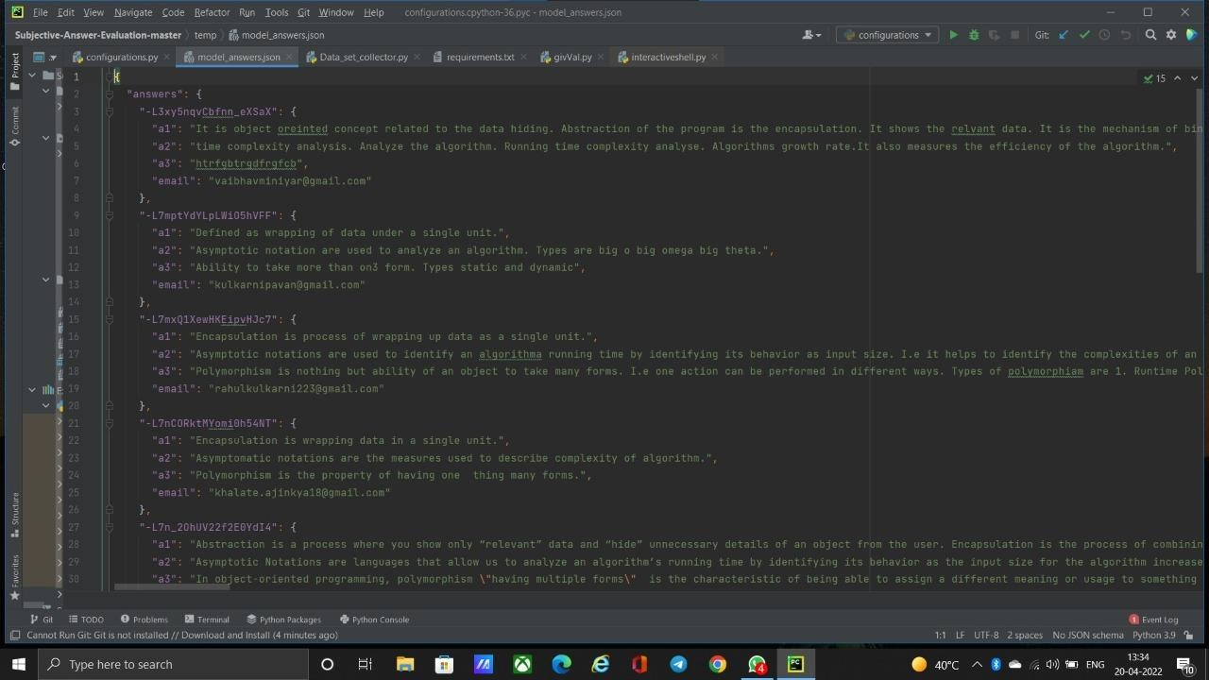

* 1. **GIV_VAL SNIPPET**

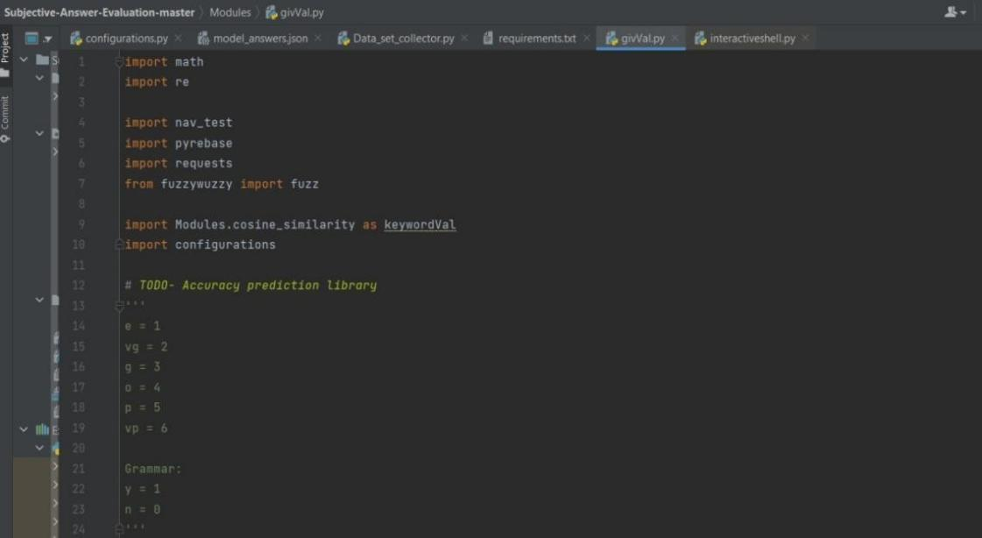

* 1. **NAV_TEST SNIPPET**

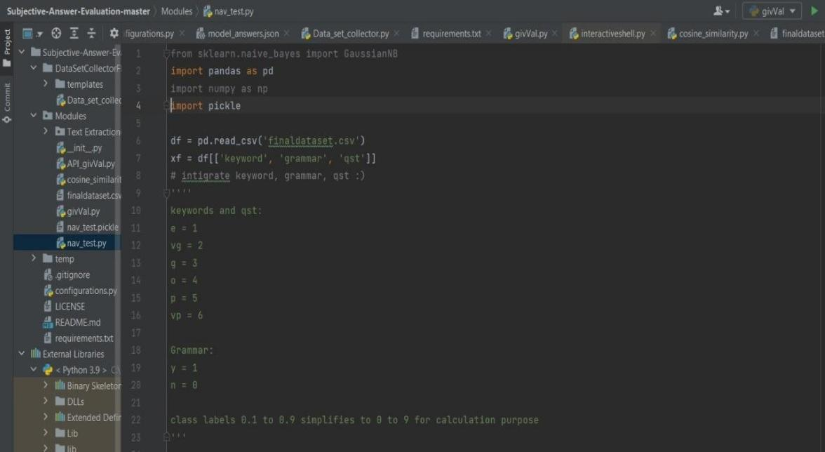

# TESTING

##### TESTING

* 1. **INTRODUCTION TO TESTING**

The purpose of testing is to discover errors. Testing is the process of trying to discover very conceivable fault or weakness in a work product. It provides a way to check the functionality of components, sub-assemblies, assemblies and/or a finished product. It is the process of exercising software with the intent of ensuring that the Software system meets its requirements and user expectations and does not fail in an unacceptable manner. There are various types of test. Each test type addresses a specific testing requirement.

##### TYPES OF TESTING

##### UNIT TESTING

Unit testing involves the design of test cases that validate that the internal program logic is functioning properly, and that program inputs produce valid outputs. All decision branches and internal code flow should be validated. It is the testing of individual software units of the application .it is done after the completion of an individual unit before integration. This is a structural testing, that relies on knowledge of its construction and is invasive. Unit tests perform basic tests at component level and test a specific business process, application, and/or system configuration. Unit tests ensure that each unique path of a business process performs accurately to the documented specifications and contains clearly defined inputs and expected results.

##### INTEGRATION TESTING

Integration tests are designed to test integrated software components to determine if they actually run as one program. Testing is event driven and is more concerned with the basic outcome of screens or fields. Integration tests demonstrate that although the components were individually satisfaction, as shown by successfully unit testing, the combination of components is correct and consistent. Integration testing is specifically aimed at exposing the problems that arise from the combination of components.

* + 1. **FUNCTIONAL TESTING**

Functional tests provide systematic demonstrations functions tested are available as that specified by the business and technical requirements, system documentation, and user manuals.

Functional testing is centered on the following items:

Valid Input : identified classes of valid input must be accepted.

Invalid Input : identified classes of invalid input must be rejected.

Functions : identified functions must be exercised.

: identified classes of application outputs must be

Output Systems /

exercised.

Procedures : interfacing systems or procedures must be invoked.

Organization and preparation of functional tests is focused on requirements, key functions, or special test cases. In addition, systematic coverage pertaining to identify Business process flows; data fields, predefined processes.

##### TEST CASES

###### Writing test

|  |  |  |  |  |
| --- | --- | --- | --- | --- |
| Test case ID | Test case name | Purpose | Test Case | Output |
| 1 | Student writes test | Use it for writing online exam | The user writes exam | Exam completed |

###### Evaluation

|  |  |  |  |  |
| --- | --- | --- | --- | --- |
| Test case ID | Test case name | Purpose | Input | Output |
| 1 | Giv val | To Evaluate the answers written by student. | User provides descriptive answers as input. | Answers are evaluated and marks are awarded. |

# CONCLUSION

### 7.CONCLUSION & FUTURE SCOPE

##### PROJECT CONCLUSION

Many schools, colleges and universities and many others educational institutes conduct the online exam. But these examinations only include multiple choice questions. These type of exam is efficient to check the student’s aptitude skill, but MCQ type exams are not able check the theoretical knowledge of the student.

The AI MODEL FOR DIGITAL EVALUATION OF DESCRIPTIVE ANSWERS attempts to

calculate the subjective answers. It calculates the student’s answer based on the keywords. By judging against the model answer and the student’s answer marks are allocated to the student. Therefore, our proposed system can evaluate MCQ as well as one sentence question. Further it can be extended to evaluate answers written in other language and mathematical expression also

The advantage of the system lies in the fact that it uses a weighted average of the closest to accurate techniques to provide the most optimized result. AI MODEL FOR DIGITAL EVALUATION OF DESCRIPTIVE ANSWERS is a systematic and reliable system which eases the role of evaluators and provides faster and more efficient outputs. This system offers a reliable, robust, and obvious short response time result. In the future, a system can be developed to evaluate diagrams as well as tables, an inbuilt system can also be made to type and make diagrams to shift examinations from handwritten paper based to completely online.

##### FUTURE SCOPE

This model can be updated to evaluate answers written in other language and mathematical expression whereas the current approach is only limited to one language and only supports text. In the future, a system can be developed to evaluate diagrams as well as tables, an inbuilt system can also be made to type and make diagrams to shift examinations from handwritten paper based to completely online and also integrate compiler to support programming language

# 8.BIBLIOGRAPHY

### 8.BIBLIOGRAPHY

##### REFERENCES

1. P.A.A. Dumal, W.K.D Shanika, S.A.D Pathinayake and T.C. Sandanayake.: Adaptive and Automated Online Assessment Evaluation System. In: 2017 11th International Conference (SKIMA)
2. Nisarg Dave, Harsh Mistry and Jai Prakash Vera, Assist. Prof.: Text Data Analysis: Computer Aided Automated Assessment System. In: IEEE-CICT 2017, 978-1-5090-6218-8/17/$31.00 ©2017

IEEE

1. Dharma Reddy Tetali, Dr. Kiran Kumar G and Lakshmi Ramana.: A Python Tool for Evaluation of Subjective Answers (APTESA). IJMET Volume 8, Issue 7, July 2017, pp. 247–255, Article ID:

IJMET_08_07_029

1. Prince Sinha, Sharad Bharadia, Dr. Sheetal Rathi and Ayush Kaul.: Answer Evaluation Using Machine Learning. In: https://[www.researchgate.net/publication/333856264,](http://www.researchgate.net/publication/333856264) March 2018
2. Ms. Shweta M. Patil and Prof. Ms. Sonal Patil.: Evaluating Student Descriptive Answers Using Natural Language Processing. (IJERT) ISSN: 2278-0181 Vol. 3 Issue 3, March – 2014

##### GITHUB REPOSITORY LINK

[https://github.com/mahesh-chenna/AI-MODEL-FOR-DIGITAL-EVALUATION-OF-DESCRIPTIVE-](https://github.com/mahesh-chenna/AI-MODEL-FOR-DIGITAL-EVALUATION-OF-DESCRIPTIVE-ANSWERS) ANSWERS

# 9.JOURNAL

**AI Model for Digital Evaluation of Descriptive Answers**

**Mr. A. Kiran Kumar*1, Chenna Mahesh*2, P. Hemanth*3, A. Venkat Vijay*4**

*1Assistant Professor, Department of Computer Science And Engineering, CMR Technical Campus, Hyderabad, Telangana

*2,3,4Student, Department of Computer Science And Engineering, CMR Technical Campus, Hyderabad, Telangana

*****************

**ABSTRACT**

Evaluation of answer papers can be bifurcated into two main types, videlicet, objective answerevaluation, and descriptive answer evaluation. The methodology of objective answer evaluation isvastly used for maximum entrance examinations. These exams are evaluated on machines as theyconducted on machines and therefore their evaluation is easy The reason behind doing so is that it tests thelogical as well as the reasoning capability of a pupil while also being extremely accurate andEffective. Every year many examinations are conducted like competitive,institutional,and non-institutional which students apply. Competitive and entrance exams typically contain objectives i.e fill in the blanks or multiple-choice questions.Although this approach is liable, it's close to impossible to execute such a system at theinstitute ranking for assessing the semester examinations of engineering scholars. One of the majorlimitations of objective examinations is that they fail to track how well a pupil has graspeda particular subject. Manual evaluation of descriptive answers is an error- prone, tedious, and time-taking activity there is hence a need for a system that automates the task of repetitious answersheet corrections and provides optimal perfection. our proposed model has come up with a reliablesystem predicated on former work that formulates the marks scored by the pupil grounded on thesentence similarity, Jaccard similarity, and grammar of the model answer and pupil answer.

**Keywords:** descriptive, processing, evaluating, grammar, database, extraction, sentence similarity, Natural Language Processing (NLP).

**Introduction**

Generally, all educational, and non-educational institutions conduct examinations. The questions asked in the examinations can be either descriptive or objective or both. Once the answers are submitted they need to be evaluated, Considering the criteria competitive examinations generally consist of objective or multiple-choice questions. These are evaluated on the system itself. Considering criteria like descriptive answers evaluation, answers given by the students are evaluated manually by the faculty. This process is error-prone, as different professors are likely to award different marks to the same answer. Manual evaluation is a time taking process, and any delay in this process would eventually lead to a delay in the release of results and discomfort to the students. For illustration, Every year about 20 Lakh engineering students give their semester subjective written examinations, which accounts for more than1.2 crore papers to be corrected every semester. These tests coincide of multiple-choice questions that include explanations as responses. Subjective questions like these are the most effective way to assess a student's understanding and play an important part in determining how well a student has understood a subject.

**Proposed system**

The goal of this proposed system is to develop a system that conducts the evaluation of descriptive answers and automatically generates the marks obtained by the student based on the percentage of accuracy present in the answer and model answer key provided. Thus we will have a system that optimizes and examines the different ways in which answers can be formed and structured and evaluates the result accordingly. The standard answer written by the student is stored in the database with the description meaning and keywords. Then it will evaluate each answer by matching the keywords as well as their synonyms or sentence similarity with the standard answer. It will also check the grammar and spelling of the words. After the evaluation, it will grade the answer depending on the correctness of the answer and keyword accuracy.

**Methodology**

The system comprises six modules they are Login module, upload answer module, Processing module Database module, answer comparison and Result Generation module.

1. **Login**: The admin is authenticated using his user id and password. Once authentication is done, the admin can add questions and their respective answers to the database. The admin can also add subjects, students, and tests for those students. The user logs in with the test link provided by the admin password If all the credentials are satisfied then the student is redirected to the page where the question and a text box for the answer are displayed.User has to write the answers to the questions. After completing the answer, he or she can submit the answer for evaluation.
2. **Upload Answers**: The upload Answers module is a module where the answers and model answers are uploaded. Keywords are extracted from the model answer and the answer submitted by the user. The keywords provide increase accuracy in the answer. The keywords that are repeated very often in the answer are given less value. But the keywords which appear frequently in the answer will have great importance..

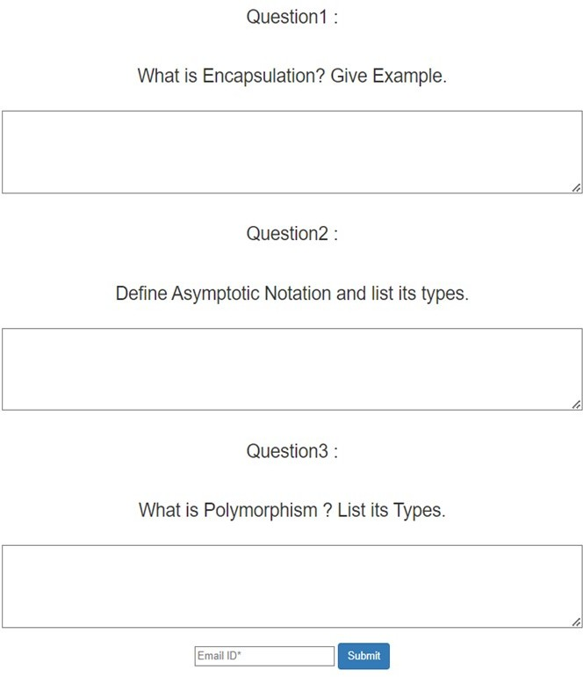

**Fig 1: student’s view to upload answer**

1. **Processing Module:** In this Module the Answers are Processed and sent to Database After taking inputs from the user, both the solution and the answer go through some preprocessing steps, which involve
2. **Keywords:** The keywords are checked in the student‟s answer and depending upon the keywords present in the student‟s answer, marks are allocated. These keywords from the standard answer are stored in a multidimensional array. Firstly, the answer written by the student is broken down into strings and stored in a multidimensional array. After this, the keywords from the model answer are compared with the student‟s answer array one by one

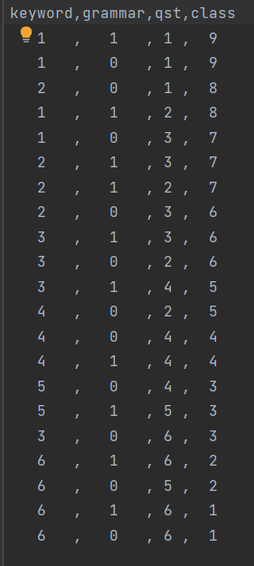

**Fig 2: Marking based on keyword and grammar**

1. **Grammar:** The structure of the sentence is formed by using Grammar. The user may only write the keywords and form sentence not related to the answer. Hence checking whether the answer is grammatically correct or not, is important in descriptive answer evaluation. To secure the highest marks the student must include the keywords in proper sentence formation.

**Grammar involves the following:**

* **Sentence Similarity:** This process involves checking of similarity between both student‟s answers and model answer. It determines similarity between the words of both the answer to predict the weight age of the key words .It also checks the spelling errors in the student‟s answer
* **Sentence formation**: Only if the sentences are grammatically correct then only marks for grammar are given.

1. **Database module:** Database is used to store the data and to get data when required. Here in this database the model answer is uploaded by the admin and the solution which is uploaded bay the student is also stored these model answers and the solutions are further used to train the model and evaluate the solutions submitted by the student. The database also stores the marks secured by the students .
2. **Answer comparison:** The Student Answers and Model Answers are Compared in this Module. After taking inputs from the user, both the solution and the answer go through some preprocessing steps, which involve tokenization, stemming, lemmatization, stop words removal, case folding, finding, and attaching synonyms to the text
3. **Results:** In this Module the Answers are Weighted and Marks are Projected to the User. It takes input from the learning module and validates the overall score with the class obtained from the learning module. Suppose the class matches the score. The score is considered finalized. If the class does not match the score, then the addition or deduction of half the

number of values in that range is made based on whether the model suggested score is greater or lesser than the Similarity equivalent score

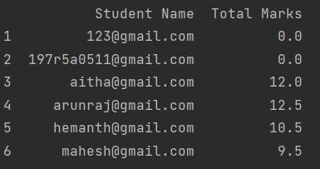

**Fig. 3: results of our model**

The above figure is the final result of our model where the student‟s answers are evaluated with reference to the trained model answers . the below figure is the accuracy of our model.

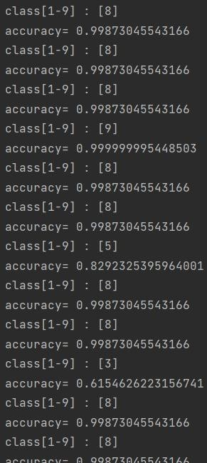

**Fig. 4: Accuracy of the model**

**Conclusion**

The AI MODEL FOR DIGITAL EVALUATION OF DESCRIPTIVE ANSWERS attempts to calculate the subjective answers. It calculates the student‟s answer grounded on the keywords. By judging against the model answer and the student‟s answer marks are allocated to the student. thus, our proposed system can evaluate descriptive answers and MCQs. Further, it can be extended to evaluate answers written in other languages and mathematical expressions also The advantage of the system lies in the fact that it uses a weighted average of the closest to accurate ways to give the most optimized result

AI MODEL FOR DIGITAL EVALUATION OF DESCRIPTIVE ANSWERS is an organized and dependable system that eases the part of evaluators and provides rapid and more effective outputs. This system offers a dependable, robust, and egregious short response time result. In the future, a system can be developed to estimate diagrams as well as tables, an

inbuilt system can also be made to type and make diagrams to shift examinations from handwritten paper based to completely online.

**Acknowledgment**

We thank CMR Technical Campus for supporting this paper titled with "**AI Model For Digital Evaluation of Descriptive Answers**", which provided good facilities and support to accomplish our work. Sincerely thank to our Chairman, Director, Deans, Head Of the Department, Department Of Computer Science and Engineering, Guide and Teaching and Non- Teaching faculty members for giving valuable suggestions and guidance in every aspect of our work..

**References**

1. M. S. M. Patil and M. S. Patil, „„Evaluating Student descriptive answers using natural language processing,‟‟*Int. J. Eng. Res. Technol.*, vol. 3, no. 3, pp. 1716–1718, 2014.
2. P. Patil, S. Patil, V. Miniyar, and A. Bandal, „„Subjective answer evaluation using machine learning,‟‟ *Int. J. Pure Appl. Math.*, vol. 118, no. 24,pp. 1–13, 2018.
3. M. F. Bashir *et al.”*Subjective Answers Evaluation Using Machine Learning and Natural Language Processing” IEEE Access, volume 9, 2019
4. P. A. A. Dumal, W. K. D Shanika, S. A. D Pathinayake and T. C. Sandanayake, "Adaptive and Automated Online Assessment Evaluation System", *2017 11th International Conference (SKIMA)*
5. Dharma Reddy Tetali, Dr. Kiran Kumar G and Lakshmi Ramana, "A Python Tool for Evaluation of Subjective Answers (APTESA)", *IJMET*, vol. 8, no. 7, pp. 247-255, July 2017.
6. Ms. Shweta M. Patil and Prof. Ms. Sonal Patil, "Evaluating Student Descriptive Answers Using Natural Language Processing", *(IJERT)*, vol. 3, no. 3, March 2014, ISSN 2278-0181.
7. Dr Sunanda Dixit, Amith Y Bharath, M L Goutham, K Ayappa and Harshitha D, "Optical Recognition of Digital Characters Using Machine Learning", *International Journal of Research Studies in Computer Science and Engineering (IJRSCSE)*, vol. 5, no. 1, pp. 9-16, 2018.
8. Xinming Hu and Huosong Xia, *Automated Assessment System for Subjective Questions Based on LSI*.
9. Asmita Dhokrat, Gite Hanumant R, C. Namratqa Mahender, “Automatrd Answering For Subjective Exmination”, International Journal of Computer Applications (0975 – 8887) Volume 56– No.14, October 2012.

**ISSN: 2455-6211, New Delhi, India**



#### International Journal of All Research Education & Scientific Methods

**An ISO & UGC Certified Peer-Reviewed Multi-disciplinary Journal UGC Journal No.: 7647**

**Certificate of Publication**

#### Mr. A. Kiran Kumar

Assistant Professor, Department of Computer Science and Engineering, CMR Technical Campus, Hyderabad, Telangana

## TITLE OF PAPER

#### AI Model for Digital Evaluation of Descriptive Answers

has been published in

#### IJARESM, Impact Factor: 7.429, Volume 10, Issue 6, June - 2022

**Certificate Id: IJ-2706221136 Date : 27-06-2022**

**Website: [www.ijaresm.com](http://www.ijaresm.com/) Email: [editor.ijaresm@gmail.com](mailto:editor.ijaresm@gmail.com)**

**Authorized Signatory**

**ISSN: 2455-6211, New Delhi, India**



#### International Journal of All Research Education & Scientific Methods

**An ISO & UGC Certified Peer-Reviewed Multi-disciplinary Journal UGC Journal No.: 7647**

**Certificate of Publication**

#### Chenna Mahesh

Student, Department of Computer Science and Engineering, CMR Technical Campus, Hyderabad, Telangana

## TITLE OF PAPER

#### AI Model for Digital Evaluation of Descriptive Answers

has been published in

#### IJARESM, Impact Factor: 7.429, Volume 10, Issue 6, June - 2022

**Certificate Id: IJ-2706221136 Date : 27-06-2022**

**ISSN: 2455-6211, New Delhi, India**



#### International Journal of All Research Education & Scientific Methods

**An ISO & UGC Certified Peer-Reviewed Multi-disciplinary Journal UGC Journal No.: 7647**

**Certificate of Publication**

#### P. Hemanth

Student, Department of Computer Science and Engineering, CMR Technical Campus, Hyderabad, Telangana

## TITLE OF PAPER

#### AI Model for Digital Evaluation of Descriptive Answers

has been published in

#### IJARESM, Impact Factor: 7.429, Volume 10, Issue 6, June - 2022

**Certificate Id: IJ-2706221136 Date : 27-06-2022**

**ISSN: 2455-6211, New Delhi, India**



#### International Journal of All Research Education & Scientific Methods

**An ISO & UGC Certified Peer-Reviewed Multi-disciplinary Journal UGC Journal No.: 7647**

**Certificate of Publication**

#### A. Venkat Vijay

Student, Department of Computer Science and Engineering, CMR Technical Campus, Hyderabad, Telangana

## TITLE OF PAPER

#### AI Model for Digital Evaluation of Descriptive Answers

has been published in

#### IJARESM, Impact Factor: 7.429, Volume 10, Issue 6, June - 2022

**Certificate Id: IJ-2706221136 Date : 27-06-2022**